WESTERN DISTRIBUTION CENTER
(HEADQUARTER)
253 NORTH VINELAND AVE
CITY OF INDUSTRY, CA 91746

EASTERN DISTRIBUTION CENTER
4200 SHIRLEY DR.
ATLANTA, GA 3033

P. 626.956.4200
F. 626.956.4225

et2online.com

PRESS CONTACT
Adena Sperling
ET2 Lighting
253 N. Vineland Ave.
City of Industry, CA 91746
(626) 956-4200 Ext.2110 adenas@maximlighting.com

Minimal Design Aesthetics Meet Oversized Form
January 22, 2020
City of Industry, CA - ET2 brings you the Form Collection, available in two oversized styles. While the size may seem towering, the open-air design minimizes the overall footprint and allows for a clean, contemporary design that looks more like a piece of art than a light fixture. Inspired by glam decor, this unique piece accessorizes your home with its elegant structure and stunning rose gold finish.
Blurring the line between pendant and chandelier, oversized pendants allow you to make a bold statement with your home decor. The average pendant ranges from 5" - 30" wide and typically has a hanging height of approximately 24" - 30." Anything above that is categorized as an oversized pendant. While the total size of these fixtures is quite large, they don't have to be overpowering. These pendants not only light up the room but they draw your gaze upward, allowing the room to seem more elevated.
First introduced in the summer of 2018, the Form has been turning heads in showrooms ever since and has inspired others to attempt their own rendition of this stunning, timeless design. Rings of Rose Gold finish are fused together to create a soft square sculpture. These large scale pieces are not only beautiful but also functional with high powered integrated LED. This dimmable light fixture is made of stainless steel in a geometric shape, making it easy to see why this statement piece furthers ET2's cutting edge design style.
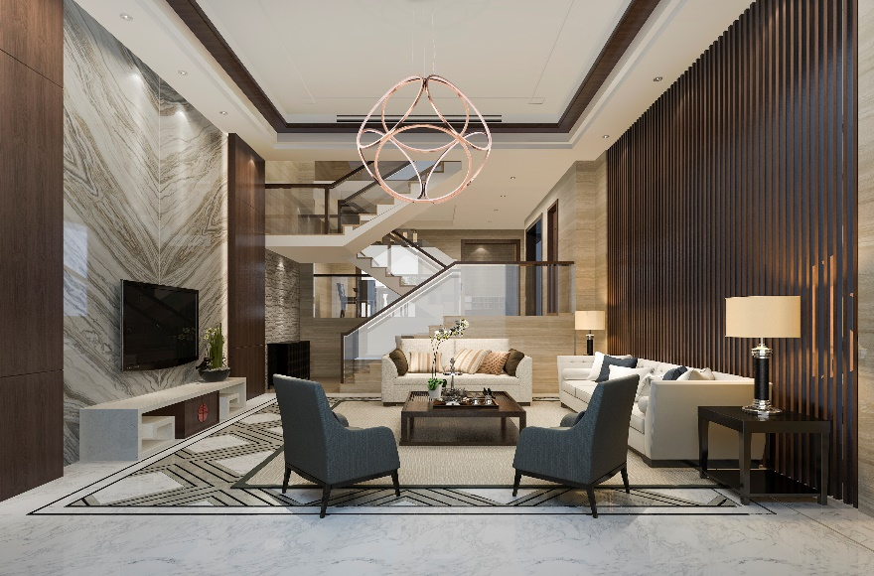
VIEW FORM COLLECTION
About ET2 Lighting
With over 6,000 products, ET2’s growth and success stems from one simple, but enduring concept— treat customers and employees like family, and never settle for less than excellence. This philosophy attracts the industry's finest designers, engineers, and manufacturers each dedicated to creating innovative lighting solutions best described as functional art.

